Who are we?
Friday, October 17, 2014
5:58 PM

We are New, Youthful, Dynamic and Technology Hungry Company with Database in our DNA.
Being a New doesn’t mean we don’t have experience, we started this company with 10 Years of Experience on Database products for worldwide customers.
We give best in class solution for Database Consulting, Database Implementation, Database support and Monitoring, Database upgrade, Database Migrations , Database Performance tuning , Database Training.
Let it be Oracle, Microsoft SQL server, MySQL, MongoDB, DB2, Sybase, EXADATA, Oracle Database Appliance, or Oracle Enterprise manager 12c, we do it all.
Although Database service is our primary focus, we still believe in taking challenges to Design and Build Applications for our customers. We work with a team of experience resources for Application Designing, Development, Testing and Support. With the new world of mobile applications we also develop customer specific mobile applications.
We believe in giving quality services with cost suitable to our customer’s pocket and on Time.
We believe in building our people and our people will build our business as they are our ambassadors. Our employees are our strength and we wish to develop them to reach greater heights by developing and sharpening their skills as per latest market trends.
We provide services onshore as well as offshore. We also cater to staff augmentations for Database Services.

Management
Friday, October 17, 2014
5:44 PM

Vinay Mistry

Technologies we work on
Friday, October 17, 2014
5:44 PM

Database Services
Oracle


MySQL

Microsoft SQL Server


IBM DB2


Sybase


Mongo DB


Application Services

Oracle Applications

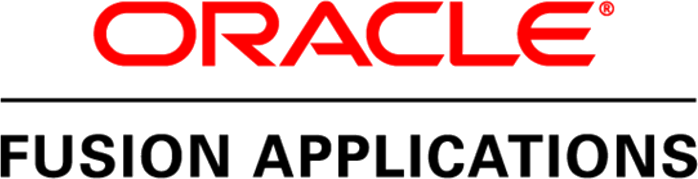

Oracle Siebel
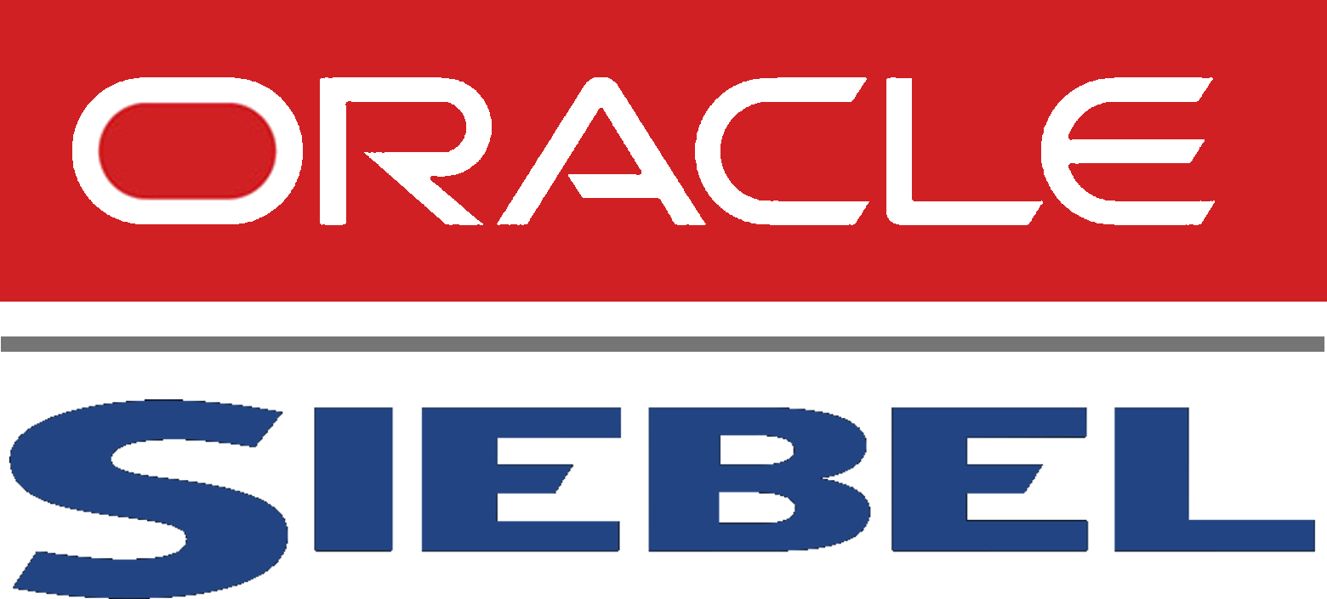

Oracle APAX


.net


PHP

Ecommerce platforms
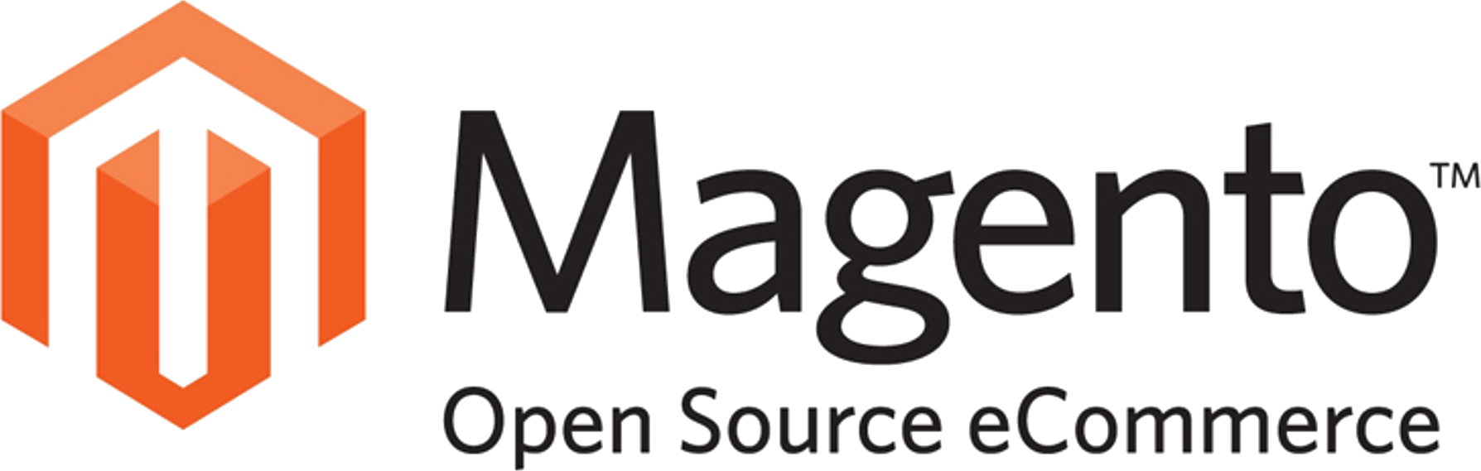



Java
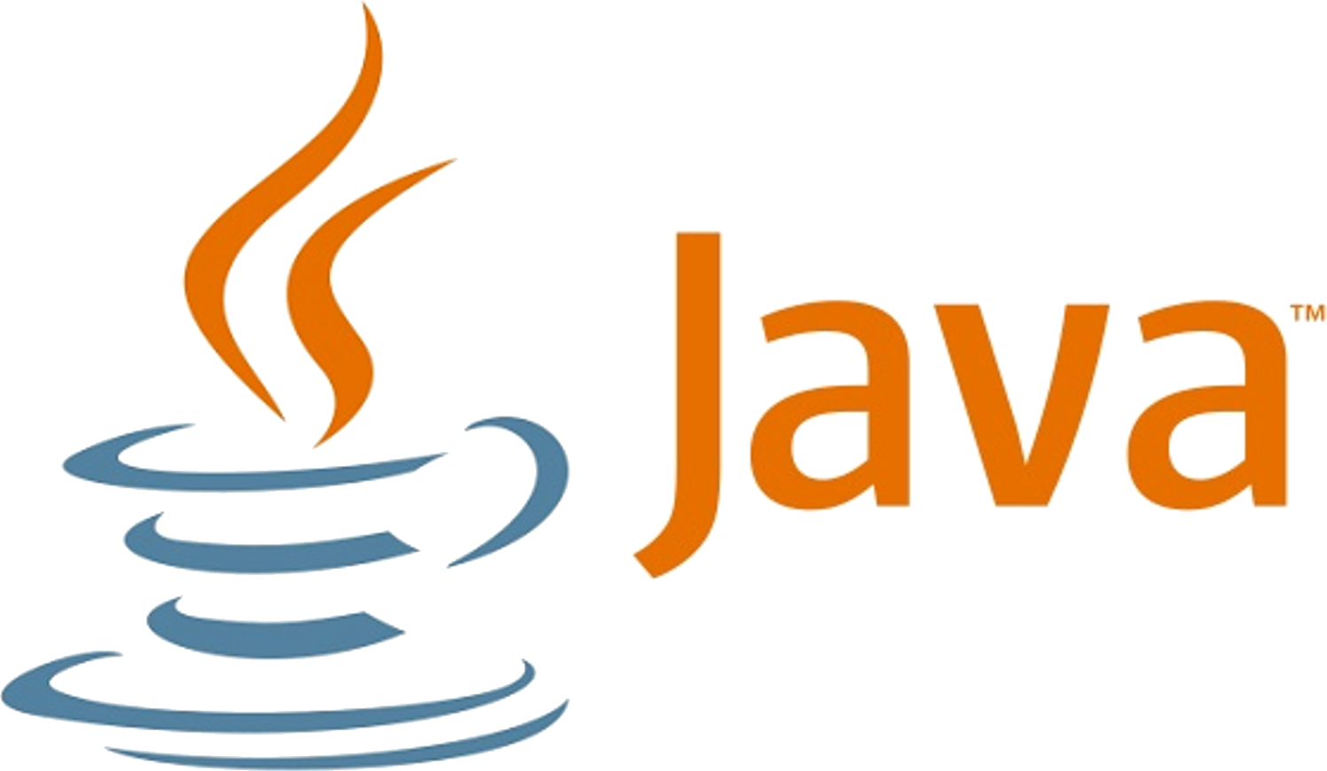

HTML 5
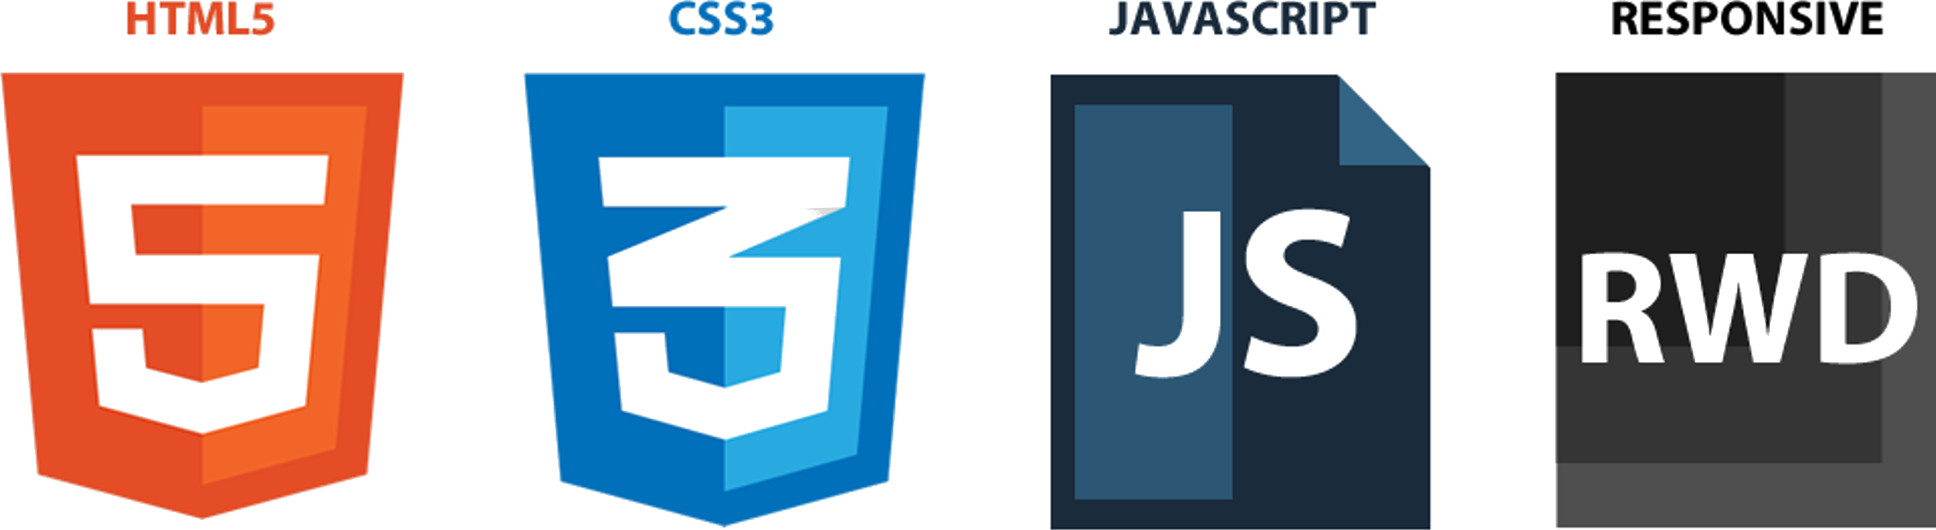

Mobile Platforms
Android


iOS




Microsoft



Our vision
Friday, October 17, 2014
5:44 PM

Our vision is to provide best and latest solutions with quality and on time delivery which will compel our customer to recommend us to their peers.
Our vision is to stand with our customers in their journey to success there by NipponITS progressing towards our Vision of being Best in the market.
We wish to provide services with unmatched satisfaction to our customers.
Our vision is to be honest and ethical in business and treat each of our customers equal.
Our vision is to give best Environment to our employees to grow in their career.

